**Phase 4: Process Automation (Admin)**

**Validation Rules**

Validation rules ensure that important healthcare data is entered correctly.

* Example: A Patient record cannot be saved without a valid Email or Phone.
* Example: A Treatment cannot be created without a Start Date.

These rules guarantee data accuracy for patient care.

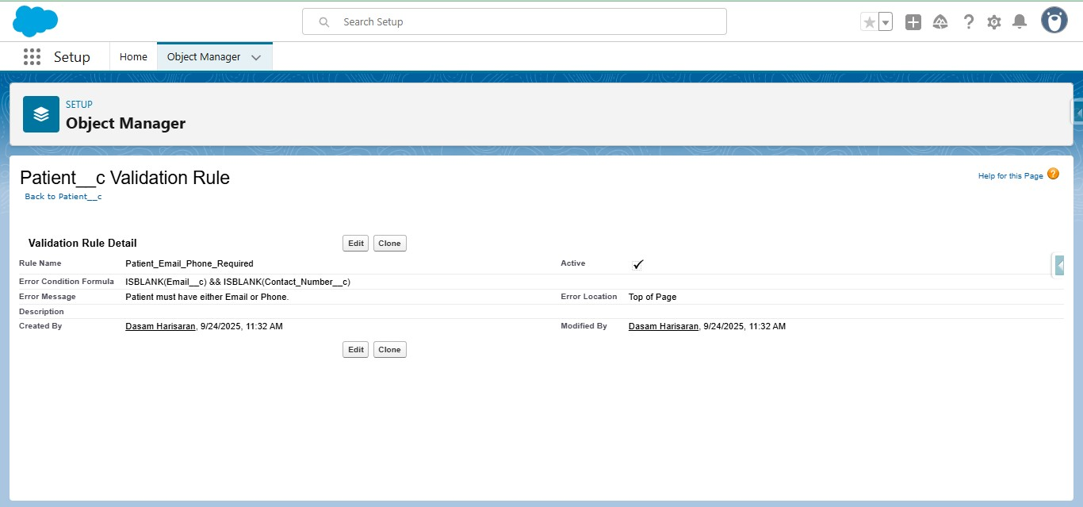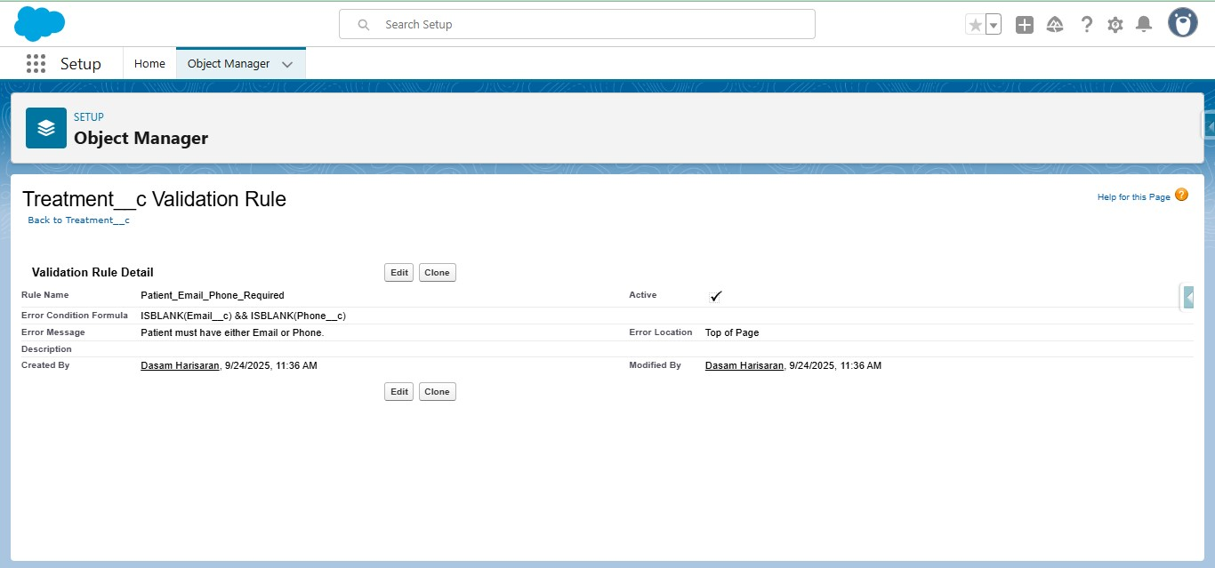

**Workflow Rules**

Workflow rules automate simple, rule-based actions.

* Example: When a Patient is marked as *Critical*, send an email alert to the assigned Doctor.
* Example: When an Appointment status changes to *Missed*, create a follow-up Task automatically.

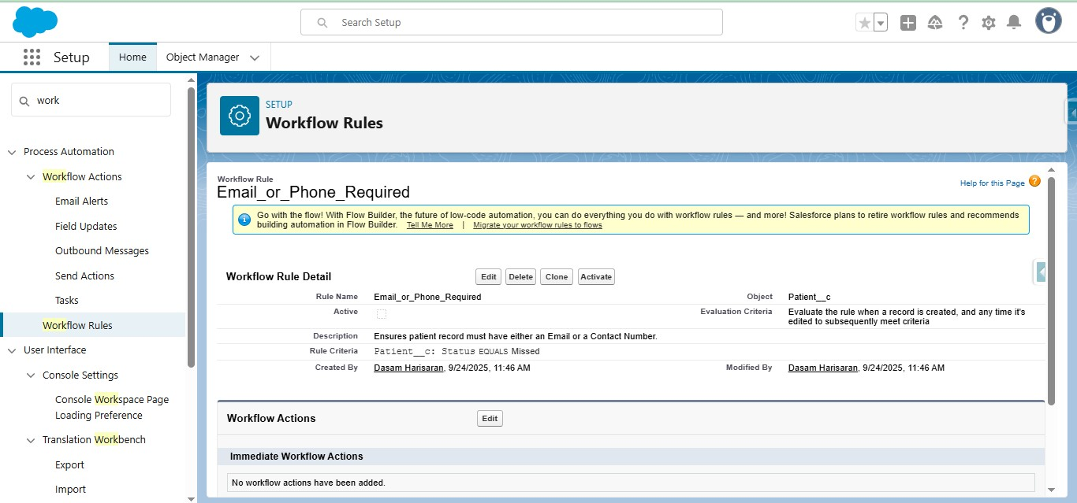

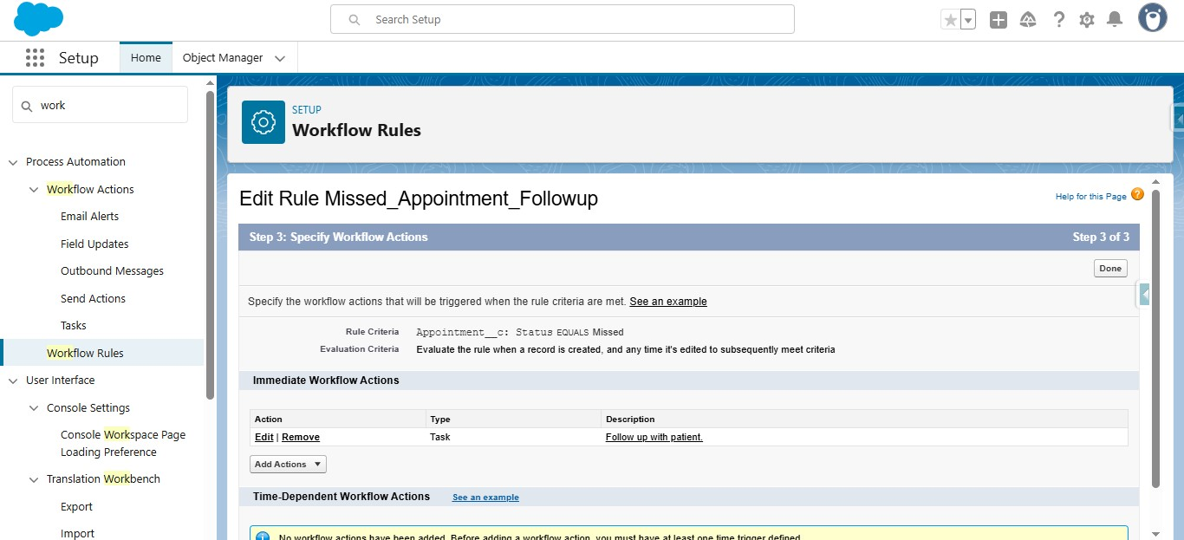

**Process Builder**

Process Builder manages more advanced automation across multiple objects.

* Example: If a Patient’s risk score falls below a threshold, automatically create a Task for the Doctor to review.
* Example: When a Care Plan is approved, notify the Care Coordinator to schedule follow-ups.

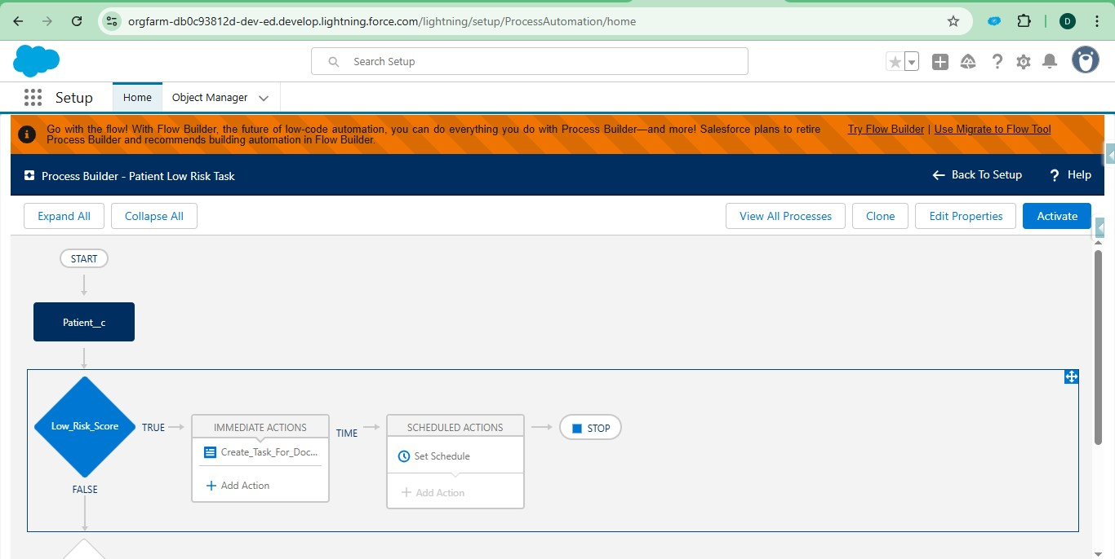

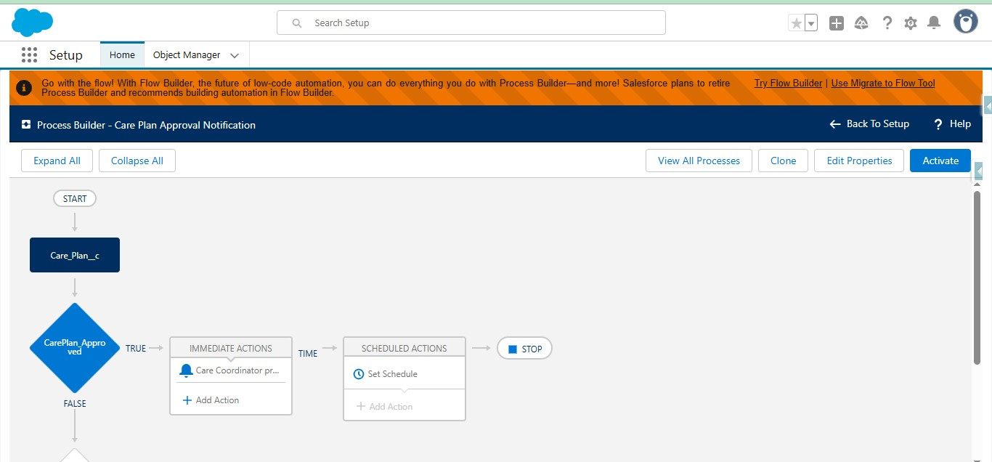

**Approval Process**

Approval processes help maintain clinical and administrative checks.

* Example: A Treatment Plan requires approval from the Department Head before being finalized.
* Example: Insurance claim requests go through a Doctor → Finance → Admin approval chain.

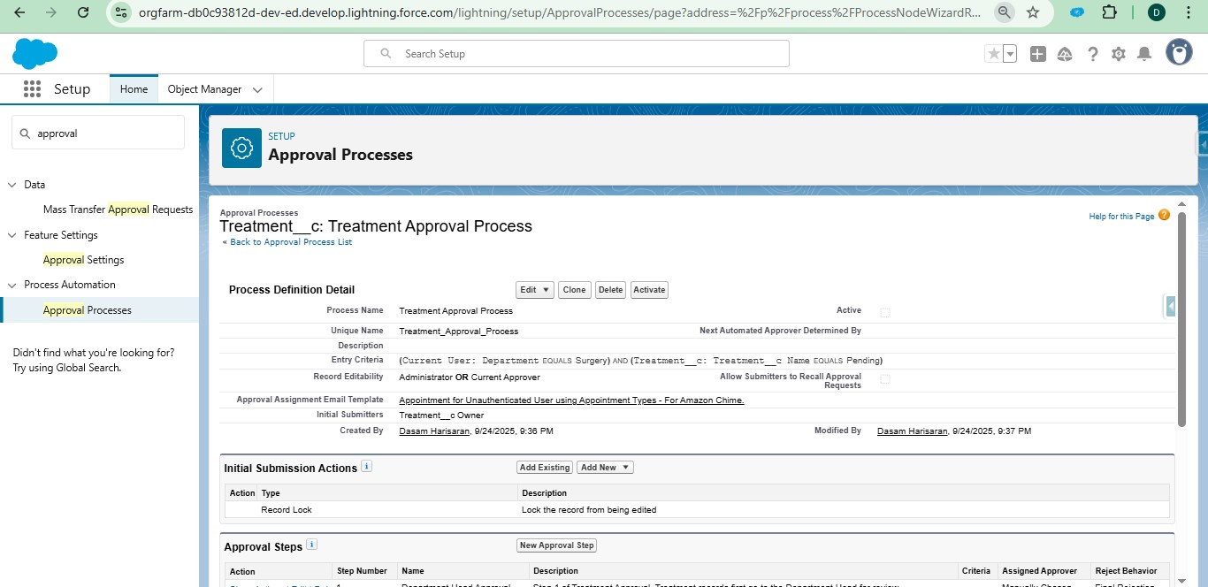

**Flow Builder**

Flows provide powerful, flexible automation. Different types of flows were implemented:

* **Screen Flow:** Collect patient intake information via a guided form.
* **Record-Triggered Flow:** When a Lab Result is entered as “Abnormal,” alert the assigned Doctor immediately.
* **Scheduled Flow:** Send follow-up reminders to Patients 24 hours before their appointment.
* **Auto-launched Flow:** Update risk score calculations in the background whenever patient vitals are updated.

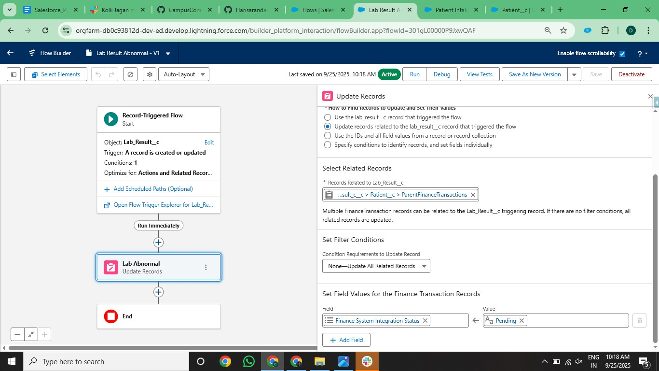

**Email Alerts**

Email templates are used to keep patients and staff informed.

* Example: Appointment confirmation email to Patients.
* Example: Lab Result notification email to Doctors.

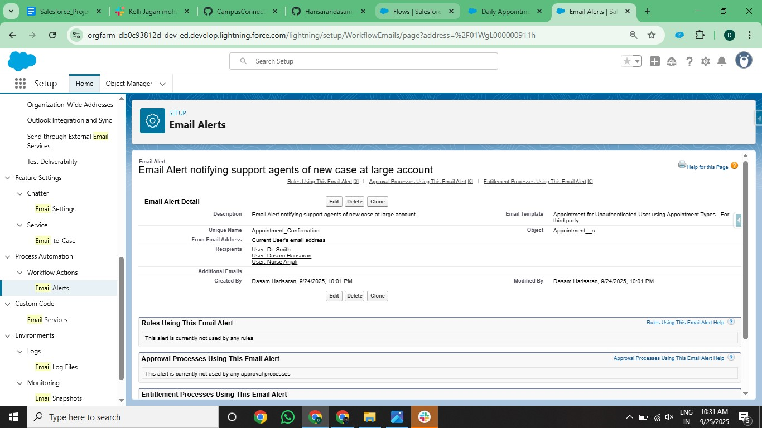

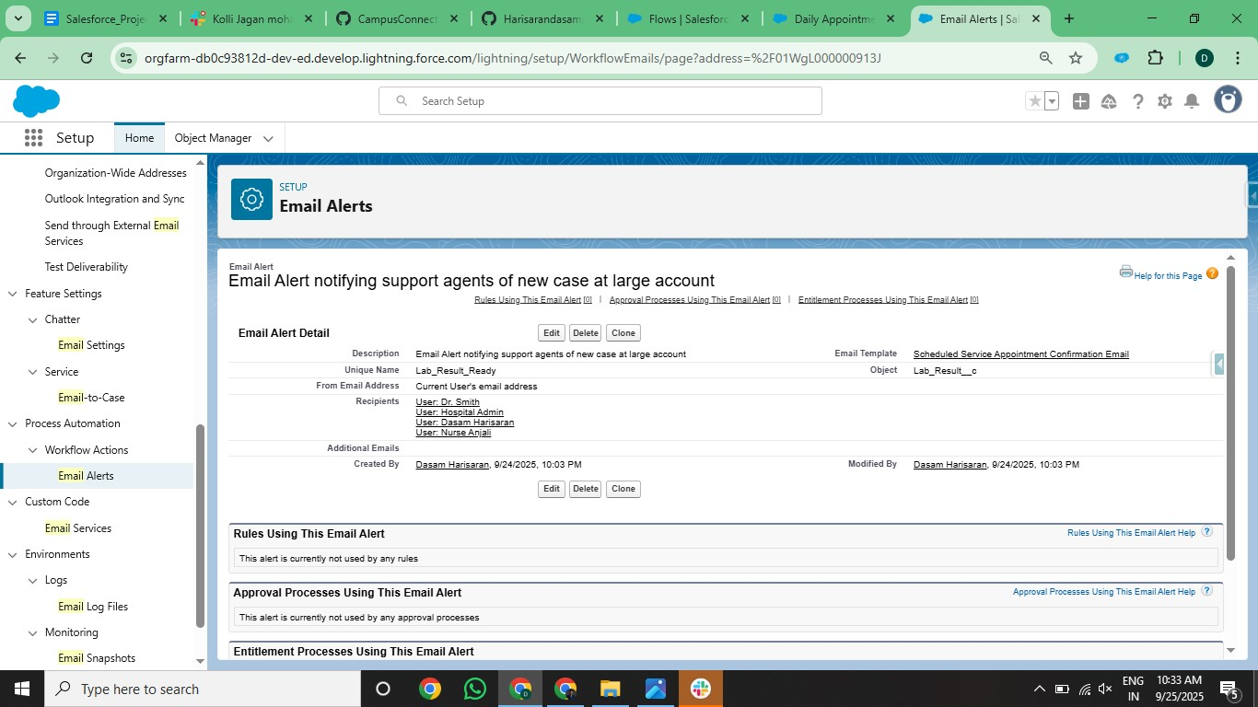

**Field Updates**

Automatic field updates reduce manual work.

* Example: When a Patient’s Appointment is marked *Completed*, automatically set Status = “Visited.”
* Example: If Treatment is approved, automatically set Status = “Active.”

**Tasks**

Tasks ensure follow-ups and reminders are never missed.

* Example: When a Care Plan follow-up is due, create a Task for the Care Coordinator.
* Example: Assign a Task to the Nurse to check patient vitals after an Appointment.

**Custom Notifications**

Custom push notifications alert users in real time inside Salesforce or on mobile.

* Example: “Patient Ravi Sharma’s lab results show abnormal values – review immediately.”
* Example: “Telemedicine appointment scheduled with Patient Anita Verma tomorrow at 10:00 AM.”

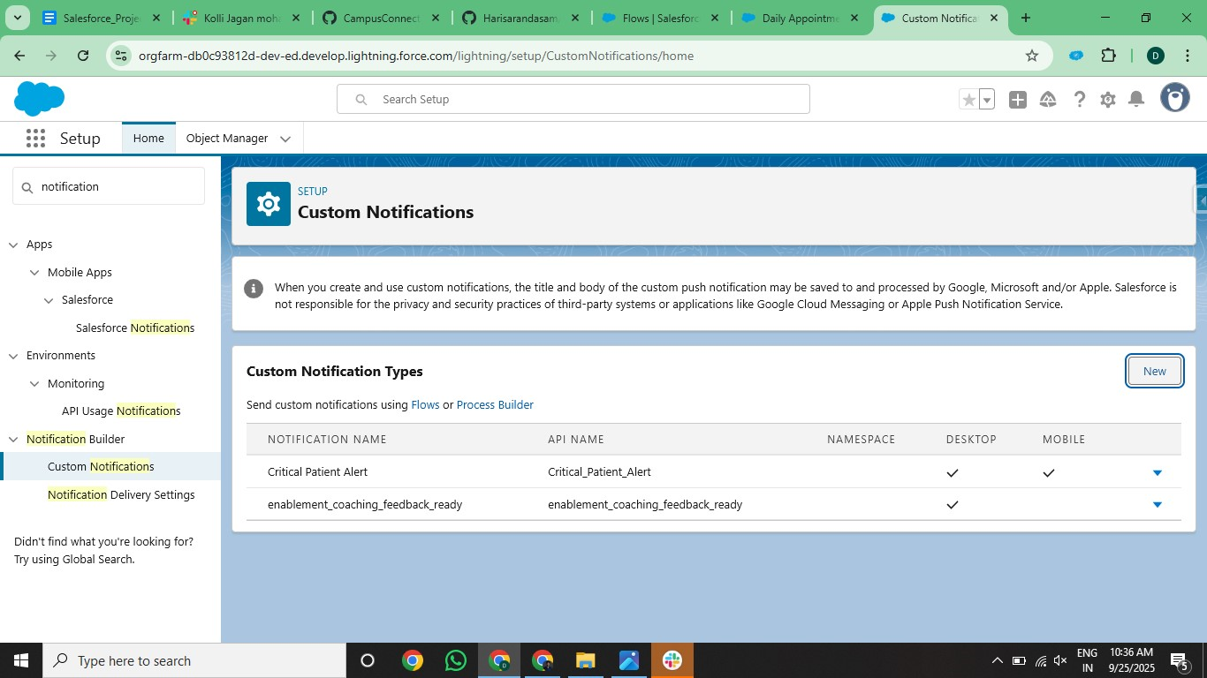

**✅ Final Deliverables (Phase 4):**

1. Validation Rules for key data fields.
2. Workflow Rules for automatic alerts and updates.
3. Process Builder automation for patient risk and care plans.
4. Approval Processes for treatments and insurance.
5. Flow Builder automation (Screen, Record-triggered, Scheduled, Auto-launched).
6. Email Alerts to patients and doctors.
7. Field Updates to reduce manual work.
8. Tasks assigned to staff.
9. Custom Notifications for urgent cases.